WEEK 9

Name of School: ……………………………….………………………………………………..….……..
Name of Teacher: …………………………………………………………………………………………
Date: |  | Day: MONDAY |  |  | Strand: MY LOCAL COMMUNITY
 |  |  |  |  | Sub Strand: Knowing The Special Leaders In Our Community And Country
Class: KG 2 |  |  | Class Size:
Content Standard:  K2.4.3.1 Demonstrate understanding and knowledge of the special leaders in our community |  |  |  | Indicator:  K2.4.3.1.1 Talk about and describe the roles of the political, traditional and religious leaders in our community  K2.4.3.1.6 Compare objects based on length and weight of various items and objects
Performance Indicator:  - Learners can talk about and describe the roles of the political, traditional and religious leaders in our community.  - Learners can compare objects based on length and weight of various items and objects. |  |  |  |  | Core Competencies:  Communication and collaboration (CC) Personal Development and Leadership (PL) Creativity and Innovation (CI) Critical Thinking and Problem Solving
Reference : KG Curriculum P.g. 150-152
Phase/Duration | Learners’ Activities |  |  |  |  | Resources
PHASE 1: STARTER | Let learners sing a song in relation to the lesson.  RCA QUESTION  1. Did you enjoy the song?  2. What words did you hear in the song?
PHASE 2: NEW LEARNING  CIRCLE TIME | Engage learners in the community circle time.  ANIMAL WALK  Your child will have fun walking just like the animals!  Help him use his imagination to move his arms, legs, head, and body.  Leaf through various picture books about animals.  As you read, encourage your kids to walk like the animals in the books.  Help them by describing and demonstrating if necessary. For instance, show them how the duck waddles, the crab moves sideways, the kangaroo leaps, the elephant lumbers, the worm inches, etc. |  |  |  |  | picture books
GROUP ACTIVITY 1  (OUTDOOR) | Follow the basic procedures of the community circle time and introduce the theme for the week.  Display a conversational poster (#14) and some concrete materials related to the theme and engage learners in active discussion.  Call on learners randomly to answer questions or contribute to the discussion.  Have learners talk about the political leaders of the country.  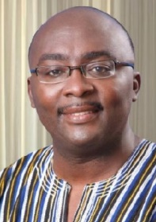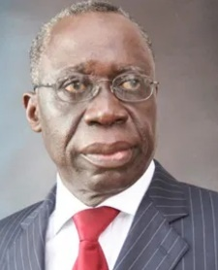  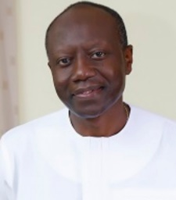  Ask learners questions that would assist them to describe the President, Ministers and Assembly Men and Women.  Assessment: Learners to talk about and play roles of some political leaders. |  |  |  |  | Pictures and videos of past and present leaders in the community, Big book
PHONICS | Engage learners to sing songs and recite some familiar rhymes that relates to the target sound.  Guide learners to pronounce and write the target sound in the sand tray or exercise books.  Have learners say three or four words that contain the target sound.  Using flash cards, learners read words that contain the target sound.  RCA QUESTIONS  1. What sound have we learnt today?  2. Which other letter sound do you know?  3. Mention any object in the classroom or home that begins with the target letter sound. |  |  |  |  | Word cards, letter cards.
GROUP ACTIVITY 2  (INDOOR) | Learners to compare the length of objects around them and those in the picture and use the words “longer than” and “shorter than” to compare length of various items measured with non-standardized scales.  Let learners also compare the weight of some objects around them and use words, “heavier than” and “lighter than”.  Get them scales and rulers to use and compare the length and height of items measured. |  |  |  |  | Big book, word card and sentence card, pictures and videos,
LEARNING CENTER | Engage learners to play freely at the learning centers.  Join in and ask learners questions frequently to guide their play. |  |  |  |  | Learning center
STORY SHARING | Tell learners a story.  Pause regularly and ask questions to make sure learners are following.  RCA QUESTION  1. Was the story interesting?  2. What part of the story did you like?  2. Retell the story to your partner.  4. what have you learnt from the story? |  |  |  |  | Word cards, letter cards.
PHASE 3: REFLECTION | Learners share what they have learnt with their peers.  Give learners homework to do at home

Date: |  | Day: TUESDAY |  |  | Strand: MY LOCAL COMMUNITY
 |  |  |  |  | Sub Strand: Knowing The Special Leaders In Our Community And Country
Class: KG 2 |  |  | Class Size:
Content Standard:  K2.4.3.1 Demonstrate understanding and knowledge of the special leaders in our community |  |  |  | Indicator:  K2.4.3.1.2 Listen attentively to the teacher-read-aloud of the big book (the chief) which relates to the theme, track words and share lessons learnt on the roles of the chiefs  K2.4.3.1.4 Blend individual letter-sound to form one syllabic words.
Performance Indicator:  - Learners can listen attentively to the teacher-read-aloud of the big book (the chief) which relates to the theme, track words and share lessons learnt on the roles of the chiefs.  - Learners can blend individual letter-sound to form one syllabic words |  |  |  |  | Core Competencies:  Communication and collaboration, Critical thinking, Personal Development and Leadership
Reference : KG Curriculum P.g. 150-152
Phase/Duration | Learners’ Activities |  |  |  |  | Resources
PHASE 1: STARTER | Let learners sing a song in relation to the lesson.  RCA QUESTION  1. Did you enjoy the song?  2. What words did you hear in the song?
PHASE 2: NEW LEARNING  CIRCLE TIME | Engage learners in the community circle time.  BACK WORDS.  Put learners into groups to play the backward game.  Start with simple sentences like “More milk please” and “Thank you.”  Say them backwards: “Please milk more” and“ You thank.”  Demonstrate a few times so she understands how to play.  Progress to longer sentences as your kids get better at playing the game. |  |  |  |  | flashcards
GROUP ACTIVITY 1  (OUTDOOR) | Read aloud the informational text which relates to the theme to the learners (Chiefs and Queen mothers).  Check on the K and W before you read the text and the L after reading.  K-Ask the learners to say what they already know about the theme.  W-Ask them to ask questions about what they want to know about the weeks’ theme.  Learners listen to the text and answer the questions they asked for the W and also for  L- Learners share what they have learnt about the theme. E.g., The Chief is the leader of the community.  Assessment: Put learners into groups to play roles of traditional leaders. |  |  |  |  | Pictures and videos of past and present leaders in the community, Big book
PHONICS | Engage learners to sing songs and recite some familiar rhymes that relates to the target sound.  Guide learners to pronounce and write the target sound in the sand tray or exercise books.  Have learners say three or four words that contain the target sound.  Using flash cards, learners read words that contain the target sound.  RCA QUESTIONS  1. What sound have we learnt today?  2. What other letter sound do you know?  3. Mention any object in the classroom or home that begins with the target letter sound. |  |  |  |  | Word cards, letter cards.
GROUP ACTIVITY 2  (INDOOR) | Teach blending using a game, blend letters to form syllables.  Write the individual letters, a consonant and a vowel. Point to each letter slowly and the learners say its sound.  Then move your finger slowly under the two sounds, blending the sound together to form a syllable.  Say the whole syllable slowly and ask pupils to repeat. Practice this with learners the whole week. |  |  |  |  | Big book, word card and sentence card, pictures and videos,
LEARNING CENTER | Engage learners to play freely at the learning centers.  Join in and ask learners questions frequently to guide their play. |  |  |  |  | Learning center
STORY SHARING | Tell learners a story.  Pause regularly and ask questions to make sure learners are following.  RCA QUESTION  1. Was the story interesting?  2. What part of the story did you like?  2. Retell the story to your partner.  4. what have you learnt from the story? |  |  |  |  | Word cards, letter cards.
PHASE 3: REFLECTION | Learners share what they have learnt with their peers.  Give learners homework to do at home

Date: |  | Day: WEDNESDAY |  |  | Strand: MY LOCAL COMMUNITY
 |  |  |  |  | Sub Strand: Knowing The Special Leaders In Our Community And Country
Class: KG 2 |  |  | Class Size:
Content Standard:  K2.4.3.1 Demonstrate understanding and knowledge of the special leaders in our community |  |  |  | Indicator:  K2.4.3.1.3 Use key words about the theme to create meaningful sentences in real life situation  K2.4.3.1.5 Create art works inspired by places in our culture and country
Performance Indicator:  - Learners can use key words about the theme to create meaningful sentences in real life situation.  - Learners can create art works inspired by places in our culture and country |  |  |  |  | Core Competencies:  Communication and collaboration, Critical thinking, Personal Development and Leadership
Reference : KG Curriculum P.g. 153-155
Phase/Duration | Learners’ Activities |  |  |  |  | Resources
PHASE 1: STARTER | Let learners sing a song in relation to the lesson.  RCA QUESTION  1. Did you enjoy the song?  2. What words did you hear in the song?
PHASE 2: NEW LEARNING  CIRCLE TIME | Engage learners in the community circle time.  Read a book about cars and trucks together and study the pictures.  Cut the top and bottom off a large box, leaving the sides intact.  Guide learners to decorate the outside of the box to look like a car or truck using felt pens, stickers, etc.  When the car is finished, let your kids take a drive around the classroom.  For added fun, set up roads by laying down rope as a guide, and set up stop signs along the route.  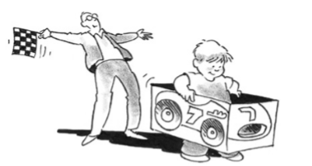 |  |  |  |  | large box, felt pens, stickers
GROUP ACTIVITY 1  (OUTDOOR) | List the key words on the board and assist learners to read them. E.g. fly whisk, durbar, chiefs, staff, umbrellas, etc.  Learners identify the new words on word cards and use them to form their own sentences. E.g. The pastor is the leader in my church.  Have learners dramatize the role of the various leaders using some of the new words  Assessment: Group learners to make simple artworks. |  |  |  |  | Pictures and videos of past and present leaders in the community, Big book
PHONICS | Engage learners to sing songs and recite some familiar rhymes that relates to the target sound.  Guide learners to pronounce and write the target sound in the sand tray or exercise books.  Have learners say three or four words that contain the target sound.  Using flash cards, learners read words that contain the target sound.  RCA QUESTIONS  1. What sound have we learnt today?  2. What other letter sound do you know?  3. Mention any object in the classroom or home that begins with the target letter sound. |  |  |  |  | Word cards, letter cards.
GROUP ACTIVITY 2  (INDOOR) | Using a picture, have learners talk about elements in the palace which interests them.  Guide them to make a picture of the umbrella and label it nicely |  |  |  |  | Big book, word card and sentence card, pictures and videos,
LEARNING CENTER | Engage learners to play freely at the literacy center.  Letter puzzle – children complete the letter puzzles by matching the capital letters to the lowercase letters  Join in and ask learners questions frequently to guide their play. |  |  |  |  | Learning center
STORY SHARING | Tell learners a story.  Pause regularly and ask questions to make sure learners are following.  RCA QUESTION  1. Was the story interesting?  2. What part of the story did you like?  2. Retell the story to your partner.  4. what have you learnt from the story? |  |  |  |  | Word cards, letter cards.
PHASE 3: REFLECTION | Learners share what they have learnt with their peers.  Give learners homework to do at home

Date: |  | Day: THURSDAY |  |  | Strand: MY LOCAL COMMUNITY
 |  |  |  |  | Sub Strand: Knowing The Special Leaders In Our Community And Country
Class: KG 2 |  |  | Class Size:
Content Standard:  K2.4.3.1 Demonstrate understanding and knowledge of the special leaders in our community |  |  |  | Indicator:  K2.4.3.1.2 Listen attentively to the teacher-read-aloud of the big book (The Chief) which relates to the theme, track words and share lessons learnt on the roles of the chiefs  K2.4.3.1.3 Use key words about the theme to create meaningful sentences in real life situation  K2.4.3.1.6 Compare objects based on length and weight of various items and objects
Performance Indicator:  - Learners can listen attentively to the teacher-read-aloud of the big book (The Chief) which relates to the theme, track words and share lessons learnt on the roles of the chiefs.  - Learners can use key words about the theme to create meaningful sentences in real life situation.  - Learners can compare objects based on length and weight of various items and objects. |  |  |  |  | Core Competencies:  Communication and collaboration, Critical thinking, Personal Development and Leadership
Reference : KG Curriculum P.g. 150-152
Phase/Duration | Learners’ Activities |  |  |  |  | Resources
PHASE 1: STARTER | Let learners sing a song in relation to the lesson.  RCA QUESTION  1. Did you enjoy the song?  2. What words did you hear in the song?
PHASE 2: NEW LEARNING  CIRCLE TIME | Engage learners in the community circle time and play the “Can you guess” game.  Select an interesting and easily visible item located in the room.  Tell your kids you are thinking about something in the room and give them clues such as color, size, or shape.  Have them try to guess the item.  If they guess incorrectly, give them another clue and let them guess again.  Continue as they guess correct. |  |  |  |  | Flashcards
GROUP ACTIVITY 1  (OUTDOOR) | Read aloud the informational text again which relates to the theme to the learners (Chiefs and Queen mothers).  Check on the K and W before you read the text and the L after reading.  K-Ask the learners to say what they already know about the theme.  W-Ask them to ask questions about what they want to know about the weeks’ theme.  Learners listen to the text and answer the questions they asked for the W and also for L- Learners share what they have learnt about the theme. E.g., The Chief is the leader of the community.  List the key words on the chalk /white board and assist learners to read them. E.g. fly whisk, durbar, chiefs, staff, umbrellas, etc.  Learners identify the new words on word cards and use them to form their own sentences. E.g. The imam is the leader of the Muslims.  Have learners dramatize the role of the various leaders using some of the new words  Assessment: learners use key words about the theme to create meaningful sentences in real life situation |  |  |  |  | Pictures and videos of past and present leaders in the community, Big book
PHONICS | Engage learners to sing songs and recite some familiar rhymes that relates to the target sound.  Guide learners to pronounce and write the target sound in the sand tray or exercise books.  Have learners say three or four words that contain the target sound.  Using flash cards, learners read words that contain the target sound.  RCA QUESTIONS  1. What sound have we learnt today?  2. Which other letter sound do you know?  3. Mention any object in the classroom or home that begins with the target letter sound. |  |  |  |  | Word cards, letter cards.
GROUP ACTIVITY 2  (INDOOR) | Learners to compare the length of objects around them and those in the picture and use the words “longer than” and “shorter than” to compare length of various items measured with non-standardized scales.  Let learners also compare the weight of some objects around them and use words, “heavier than” and “lighter than”.  Get them scales and rulers to use and compare the length and height of items measured. |  |  |  |  | Poster/ cut out, picture of important individuals in the community. Ghana map, Cut out shapes, big books, counters, crayons
LEARNING CENTER | Engage learners to play freely at the learning centers.  Join in and ask learners questions frequently to guide their play. |  |  |  |  | Learning center
STORY SHARING | Tell learners a story.  Pause regularly and ask questions to make sure learners are following.  RCA QUESTION  1. Was the story interesting?  2. What part of the story did you like?  2. Retell the story to your partner.  4. what have you learnt from the story? |  |  |  |  | Word cards, letter cards.
PHASE 3: REFLECTION | Learners share what they have learnt with their peers.  Give learners homework to do at home

Date: |  | Day: FRIDAY |  |  | Strand: MY LOCAL COMMUNITY
 |  |  |  |  | Sub Strand: Knowing The Special Leaders In Our Community And Country
Class: KG 2 |  |  | Class Size:
Content Standard:  K2.4.3.1 Demonstrate understanding and knowledge of the special leaders in our community |  |  |  | Indicator:  K2.4.3.1.1 Talk about and describe the roles of the traditional and religious leaders in our community  K2.4.3.1.4 Blend individual letter-sound to form one syllabic words
Performance Indicator:  - Learners can talk about and describe the roles of the traditional and religious leaders in our community.  - Learners can blend individual letter-sound to form one syllabic words. |  |  |  |  | Core Competencies:  Communication and collaboration, Critical thinking, Personal Development and Leadership
Reference : KG Curriculum P.g. 150-152
Phase/Duration | Learners’ Activities |  |  |  |  | Resources
PHASE 1: STARTER | Let learners sing a song in relation to the lesson.  RCA QUESTION  1. Did you enjoy the song?  2. What words did you hear in the song?
PHASE 2: NEW LEARNING  CIRCLE TIME | Engage learners in the community circle time.  Sit the children in a circle, facing inwards.  One child is chosen to be “it”. it walks around the circle, gently tapping each other player in turn on the head or shoulder, naming each player as a ‘Duck’. When ready, it chooses one player to be the ‘Goose’ – tapping that player on the head and shout ‘Goose’.  The player selected as Goose stands up and chase It around the circle, trying to tap her before she gets all the way around the circle to sit back in the spot where the Goose was originally sitting.  If the Goose is not able to tag the It, then Goose becomes It and the game continues.
GROUP ACTIVITY 1  (OUTDOOR) | Display a conversational poster (#14) and some concrete materials related to the theme and engage learners in active discussion.  Call on learners randomly to answer questions or contribute to the discussion.  Have learners talk about the traditional and religious leaders of the country.  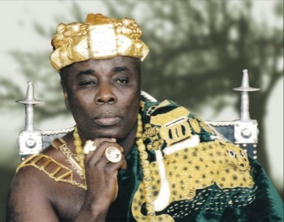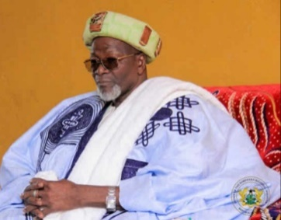  Aboatia Ofori Panin  Yaa Naa Abukari  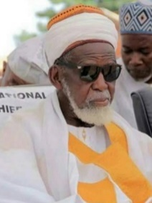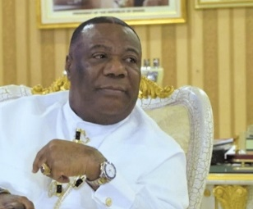  Bishop Duncan Williams  Shelkh Osman Nuhu  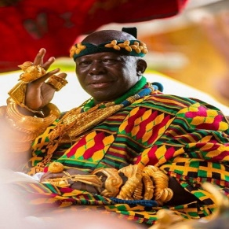  Otumfuo Osei Tutu II  Talk about the traditional leaders and where they can be found.  Ask those who have seen their chiefs to describe how they dress  Let learners talk about the leaders in their various religious groups. E.g. Muslins – Imam, Christians-Pastors, Catholic Father, Bishops etc.  Assessment: Learners blend individual letter-sound to form one syllabic words |  |  |  |  | Pictures and videos of past and present leaders in the community, Big book
PHONICS | Engage learners to sing songs and recite some familiar rhymes that relates to the target sound.  Guide learners to pronounce and write the target sound in the sand tray or exercise books.  Have learners say three or four words that contain the target sound.  Using flash cards, learners read words that contain the target sound.  RCA QUESTIONS  1. What sound have we learnt today?  2. Which other letter sound do you know?  3. Mention any object in the classroom or home that begins with the target letter sound. |  |  |  |  | Word cards, letter cards.
GROUP ACTIVITY 2  (INDOOR) | Teach blending using a game. Two pupils hold individual letter cards separately. They move towards each other slowly until they stand close and put their letters together to read a syllable.  Teach rhymes and songs as learners sing along  Have learners dance with actions as they sing the songs |  |  |  |  | Big book, word card and sentence card, pictures and videos,
LEARNING CENTER | Engage learners to play freely at the learning centers.  Join in and ask learners questions frequently to guide their play. |  |  |  |  | Learning center
STORY SHARING | Tell learners a story.  Pause regularly and ask questions to make sure learners are following.  RCA QUESTION  1. Was the story interesting?  2. What part of the story did you like?  2. Retell the story to your partner.  4. what have you learnt from the story? |  |  |  |  | Word cards, letter cards.
PHASE 3: REFLECTION | Learners share what they have learnt with their peers.  Give learners homework to do at home

